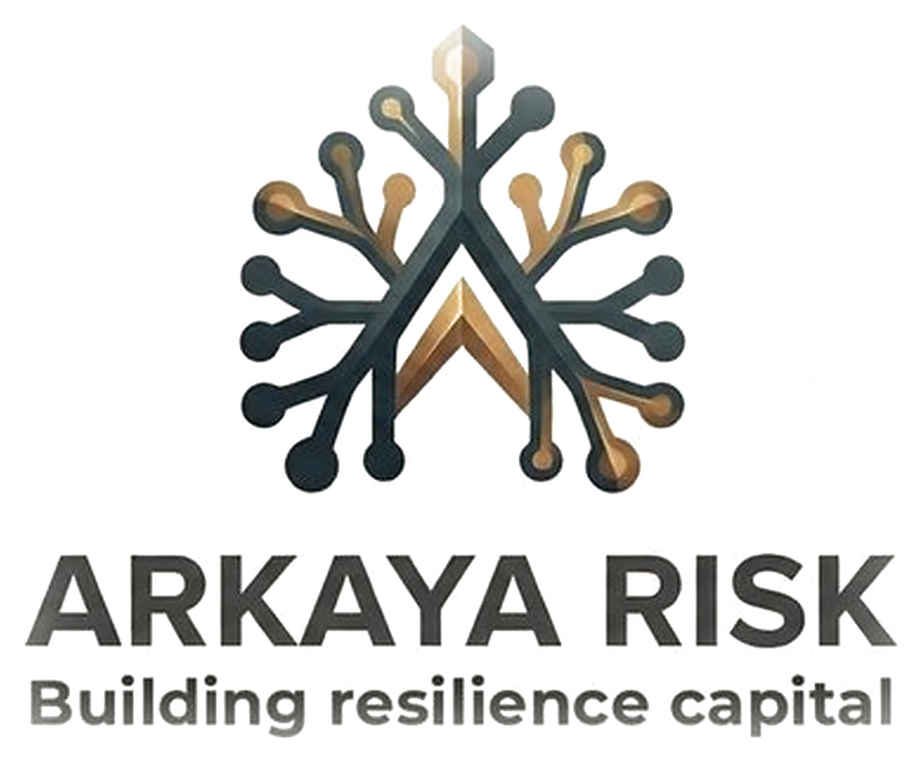

The Schema Independence Charter
Enforced separation of schema custody from commercial activity

Version: v1 Date: 19 May 2026
Status: Internal canonical reference. Counterparty-disclosable. Supersedes the bare three-sentence statement carried in the repositioning material.
Standing: Dependency for arkaya-brand-voice, arkaya-document-architecture, and the schema-neutrality discipline. The Taxonomy governs what the schema may contain; this Charter governs who decides and on what terms.
Author: David McKibbin, Arkaya Risk. Contact: djm@arkayarisk.com

1. Purpose and standing
This Charter exists because a verification layer is worth precisely as much as its independence, and independence asserted is not independence enforced. Arkaya is building the evidence layer the insurance and capital markets price governance against. The moment the entity that stewards that layer can be shown to bend it for commercial reasons, the layer is worth nothing, and a serious counterparty will look for exactly that before relying on it.
The Taxonomy already carries three disciplinary rules. Primitives are observable, not declared. Primitives are not summed into a score. The Taxonomy owns no maturity band. Those rules govern what the schema may contain. They do not govern the institution that holds it: who may overrule a schema decision, what revenue is allowed to depend on one, and what is published when a schema decision is adverse to Arkaya. This Charter governs the institution. It is the structural counterpart to the content discipline, and it is written to be interrogated, not filed.
It is counterparty-disclosable by design. A private neutrality claim is the weakest kind. The test in Section 8 is the instrument a private equity or Lloyd's counterparty is invited to run against Arkaya directly.

2. The principle this Charter enforces
The repositioning locked the principle in three sentences:
Arkaya stewards the schema. Arkaya offers product design services on top. The schema decisions are not commercial decisions.
Three sentences are a position, not a defence. A position survives a first meeting; it does not survive due diligence. The failure mode it has to defeat is documented and structural, not hypothetical.
Auditing is the cautionary precedent, not because audit is a market Arkaya competes in, but because audit is what a governance verification layer becomes if it is not firewalled. The conflict between audit opinion and consulting fee was identified, then codified in statute through the auditor-independence provisions of Sarbanes-Oxley in 2002, after Enron and the dissolution of Arthur Andersen. The separation was written into law and still leaked: Andersen had already rebuilt a consulting arm, and the same structural conflict resurfaced at Wirecard, where a roughly €1.9bn cash gap was disclosed days after conventional governance certifications and Big Four audit sign-off [1][3]. Codification did not hold. Fee gravity did.
Credit ratings are the second precedent and the closer one, because the rating agency, like Arkaya, issues a reference the market prices against. The structural defect was the issuer-pays model and the ancillary services sold alongside the rating to the entity being rated. It was named by the Financial Crisis Inquiry Commission and addressed, incompletely, by Dodd-Frank in 2010; the random-assignment remedy that would have removed the conflict at its root was proposed and not implemented [2]. The instructive detail is that the regulator is barred from policing the substance of a rating. Only the structure can be governed. The same is true here. This Charter governs the structure.

3. What counts as a schema decision
A firewall is rhetoric unless the protected class is defined precisely enough to test. The following are schema decisions. They are made under Custodian authority and are outside commercial reach. Where this Charter says a schema decision may not be commercially overridden, it means each of these.
- Inclusion or exclusion of an evidence primitive at any moment-sector cell of the Governance Evidence Taxonomy.
- The verification mode attached to a primitive, and the requirement that primitives are observable, not declared.
- Application of the no-score rule: that primitives are not summed, weighted or ranked into a single published number.
- Resolution of any maturity-calibration field to an externally owned matrix or to an explicit occupancy-pending null, and the refusal to author an internal band.
- Schema versioning: what changes between versions, what is deprecated, and the preservation of historical references across versions.
- The schema properties at Layer 1: machine-readable, cryptographically verifiable, linked-data referenced, versioned, privacy-preserving, and format-deferred to the external bodies that govern those formats.
Pricing models, underwriting appetite, product design at Layer 2 and engine implementation at the boundary are not schema decisions. They sit downstream of the schema and may move freely. The line is the Layer 1 boundary, and it is the only line this Charter polices.

4. The override prohibition
No commercial counterparty and no commercial function inside Arkaya may overrule a schema decision. This is absolute and it is the operative clause of the Charter.
Engine partners hold no privileged schema access. The position is already locked in the architecture: the first reference engine has first-mover sequence advantage, not privileged schema access, and the engine is replaceable at the interface, not at the methodology. A reference engine implements the schema; it does not author it, and engine substitution preserves counterparty continuity by design. Voyager AI, as first reference engine, is bound by this clause exactly as any successor engine would be.
Carriers, pilot clients and product-design clients are counterparties to Arkaya's commercial activity. None of them, individually or in aggregate, can cause a primitive to be added, removed, softened or rescored. A client may decline to engage. A client may not move the schema. The distinction is the whole of the neutrality claim.
Inside Arkaya, schema decisions are the Custodian's. Commercial functions advise and are heard; they do not decide and cannot veto. The Custodian of the Custos Schema is the persistent authorial role. The Founding Assessor function is operational and time-bounded and is treated in Section 7.

5. The revenue ringfence
Schema custody is not a revenue line. There is no fee for inclusion, no priority path for a paying counterparty, no expedited primitive, and no commercial tier of the schema. Pay-to-include is the issuer-pays defect transposed, and it is prohibited here in the same terms the precedent makes unavoidable [2].
Custos™ is the reference implementation and Arkaya earns from product design services at Layer 2 and, during the bounded period, from assessment. Neither revenue stream may condition a Layer 1 decision. The model adopted is the auditor-independence model applied at its strongest reading: the function that earns from a counterparty does not get to shape the standard that same counterparty is measured against [1]. Where the precedent failed it failed by erosion, not by absence of the rule, which is why the rule here is paired with the publication discipline in Section 6 and the structural handover in Section 7. A rule that depends on the rule-holder's restraint is the rule that broke twice already.

6. Publication regardless of commercial consequence
Every schema decision, version change, disciplinary-rule application and occupancy-pending null is published to the public version record. Publication does not wait on, and is not conditioned by, the consequence to Arkaya, to an engine partner, to a product-design client or to any counterparty.
A schema decision that is commercially adverse to Arkaya is published on the same terms and the same timeline as one that is not. A determination that an engine, including the reference engine, does not meet the schema is published. The Taxonomy is versioned precisely so that primitives can evolve without breaking historical references, which means the record is append-only in substance: a past decision cannot be quietly unmade. Publication is what converts the override prohibition from a promise into something a third party can check after the fact, which is the only kind of neutrality worth claiming.

7. The handover that makes the separation structural
A separation that depends on the founder choosing not to cross it is the separation that failed at Andersen and at the rating agencies. This Charter does not rely on restraint. It relies on devolution.
Arkaya is Custodian of the Custos Schema and Founding Assessor. Custodian is the persistent role. Founding Assessor is the time-bounded operational function and it ends at Custos schema major-version 4 or 13 November 2026, whichever is earlier. At handover the assessor function devolves to accredited laboratories and the Custodian role persists with the Custos Foundation. After that point the entity earning from assessment is structurally distinct from the entity holding the schema, and the separation no longer rests on Arkaya's good behaviour. It rests on the architecture.
This is the answer to the only serious objection to the three-sentence principle, which is that a slogan is not a structural separation. Until handover, the override prohibition and the publication discipline carry the separation. After handover, the institutional split carries it. The Charter is the bridge between the two states and it names the date.

8. The counterparty test
This section is the Charter demonstrating the standard it argues for. A neutrality claim that cannot be falsified is a declaration, not a claim. The following is the instrument a counterparty is invited to run against Arkaya. Each test maps to the precedent it is designed to defeat.
Test the counterparty runs | What a real separation returns | Precedent it defeats
Ask which schema decisions in the live version were commercially adverse to Arkaya, an engine partner or a paying client, and were published anyway. | A non-empty list, on the public version record, with the adverse consequence stated. | Issuer-pays ratings: adverse calls suppressed by the paying relationship [2].
Ask who can overrule a primitive inclusion, a verification mode or an occupancy-pending null, and trace the authority. | No commercial function and no engine or services counterparty in the chain. Custodian authority only. | Auditor independence: consulting fees bending the audit opinion [1].
Ask what revenue depends on a given schema decision going one way. | None. Schema custody carries no fee line and no pay-to-include path. | Ancillary services sold to the rated entity [2].
Ask what guarantees the separation after the founder is no longer the assessor. | The Custos Foundation devolution: Custodian persists, assessment devolves to accredited labs at the locked handover. | Separation codified in statute that still leaked under fee gravity [1][3].
If any cell in the middle column comes back empty, the separation is asserted and not enforced, and the counterparty is right to discount it. The Charter is written so that the cells are not empty.

9. Standing, amendment and supersession
This Charter supersedes the bare three-sentence statement wherever that statement appears in the repositioning material; the principle is retained verbatim and this instrument is the enforcement behind it. It is a dependency for arkaya-brand-voice, arkaya-document-architecture and the schema-neutrality discipline, and it is referenced, not paraphrased, by each.
Amendment is itself a schema-governance act and is subject to Section 6. A change to this Charter is published on the public version record with the reason stated, on whole-integer versioning, with no silent revision. The first issue is v1. A Charter that could be quietly weakened would defeat its own purpose, so it is governed by the discipline it imposes.
Resilience Capital is built. Not asserted.

References
Each reference carries substantive content supporting the argument. The reference block evidences the authenticate-and-verify approach the architecture proposes. Sources verified against primary records on 19 May 2026.
- Auditor independence, codified and still leaking. Sarbanes-Oxley Act of 2002, Title II, Section 201, makes it unlawful for a registered public accounting firm to provide enumerated non-audit services to an audit client. The Act was signed on 30 July 2002 after the Enron collapse and the dissolution of Arthur Andersen. The cautionary detail for this Charter is that Andersen had rebuilt a consulting arm before the rule landed, and the academic record describes the audit-consulting ties as inexorable: the conflict was legislated against and still recurred. Separation codified is not separation achieved. Used here as the model adopted at its strongest reading and as the failure this Charter is engineered against.
- Issuer-pays and ancillary services, the closer precedent. The Financial Crisis Inquiry Commission and the Senate Permanent Subcommittee on Investigations identified the issuer-pays compensation model of the principal rating agencies as a fundamental conflict, most salient in complex structured products, with ancillary services sold to the rated entity as an aggravating factor. Dodd-Frank (2010), Sections 932, 936 and 938, required internal controls and a separation of ratings analysis from sales; the Franken random-assignment remedy that would have removed the issuer-pays conflict at its root was proposed and not implemented. The SEC is statutorily barred from regulating the substance of a rating, only its structure. The structural lesson is the design principle of Sections 4 to 6.
- Wirecard, separation under fee gravity. Wirecard AG filed for insolvency at the Munich Local Court on 25 June 2020. A cash gap of roughly €1.9bn was disclosed days after the company had passed conventional governance certifications and Big Four audit sign-off. Direct evidence that an independence regime written into statute does not, by itself, make the verification reliable at the moment it is tested. Cross-referenced to the Arkaya Taxonomy v6 reference block, re-verified at v6 against primary records.
- The posture is achievable, not just defensible. Factor Analysis of Information Risk (FAIR), codified by The Open Group as the O-RT and O-RA standards, decomposes risk into measurable primitives and became an industry reference without becoming a rating agency. The ORX operational-risk loss consortium (founded 2002) and the Basel operational-risk event taxonomy show open, consensus-based evidence taxonomies achieving industry and regulatory recognition without issuing a score. These are the constructive precedents the open-schema posture follows, and they refute the assumption that a reference layer must capitalise its neutrality to survive.
- Arkaya internal anchors. Governance Evidence Taxonomy v6 (16 May 2026): the three disciplinary rules and the five schema properties this Charter pairs with an institutional discipline. The Third Domain of Risk v3 (May 2026): the closed-inputs, open-output-schema, customer-permissioned, multi-vendor-at-Layer-0 IP posture this Charter operates within. EthicalEdge GovernanceStack One-Pager v3 (13 May 2026): the locked positions that the first reference engine has first-mover sequence advantage, not privileged schema access, and that the engine is replaceable at the interface, not at the methodology. arkaya-brand-voice v8: Custodian of the Custos Schema and Founding Assessor, and the Custos Foundation handover at schema major-version 4 or 13 November 2026, whichever is earlier, which is the devolution Section 7 relies on.

